PLServer registration

PLServer.ocx is ActiveX component and must register to Window before use.  
File can locate anywhere on PC but following procedure assumes location is C:\PLServer

1. Create folder C:\PLServer into your hard drive and copy PLServer.ocx into it.
2. Run command prompt as **administrator** (See picture below. Right mouse click)  
     
   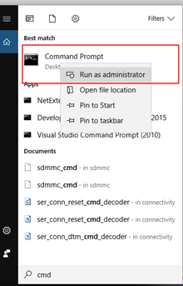
3. In command prompt window, browse to C:\PLServer
4. type: **regsvr32 plserver.ocx** hit enter→ make sure registration success.
5. If registration fails, you may need to unregister existing PLServer.ocx first. Use then **regsvr32 –u plserver.ocx** in its file location**.**
6. Run PLServer application like FastInventory (found from SDK)
7. Make sure application open and you’ll see PLServer and its header (see red square below) clicking that get about window to open. You can verify that correct PLServer version has been registered successfully.

